# ACTIVITY-01

## Factors that influence software development

Software development is a complex and dynamic process influenced by multiple factors that can impact the quality, timeline, and success of a project. These factors range from technological to

human, organizational, and external forces. Understanding these factors and how they interact can help teams navigate challenges and improve the overall success of software projects.

### Requirements and Scope Description:

* + The clarity, stability, and completeness of requirements are fundamental to software

development. If requirements are poorly defined, vague, or frequently changing, it can lead to project delays, increased costs, and quality issues.

### Influence:

* **Unclear Requirements**: Leads to confusion, errors, and the potential for scope creep (uncontrolled changes or continuous growth in the project scope).
* **Well-Defined Requirements**: Clear and stable requirements help in creating a focused development plan and reduce misunderstandings, leading to more successful outcomes.

### Technology and Tools Description:

* + The choice of technology stack, programming languages, frameworks, and development tools

greatly affects software development. The tools used for version control, testing, deployment, and collaboration can also influence the project’s success.

### Influence:

* + **Modern Tools & Frameworks**: Utilizing up-to-date technologies can improve efficiency, speed, and scalability, while also ensuring better long-term maintenance.
  + **Legacy Systems**: Working with outdated technologies may limit flexibility, increase complexity, and require additional resources to maintain.

### Team Skills and Experience Description:

* + The skillset, experience, and cohesiveness of the development team directly influence the

quality and speed of software development. Teams that are highly skilled in specific technologies and methodologies will typically produce higher-quality code faster.

### Influence:

* + **Skilled Team**: A team with experience and expertise can tackle complex problems effectively, reduce development time, and deliver quality software.
  + **Inexperienced or Under-skilled Team**: Lack of experience can lead to inefficiencies, errors, and delays. Ongoing training is key to keeping the team up-to-date with evolving technologies.

### Stakeholder Involvement and Communication Description:

* + Regular and effective communication with stakeholders (clients, end-users, business analysts) ensures that the project meets their expectations and delivers value. Feedback loops should be established to capture user needs and changes throughout development.

### Influence:

* + **Regular Feedback**: Continuous engagement with stakeholders ensures the product is on track and aligned with user needs.
  + **Poor Communication**: Can lead to misunderstandings, misaligned goals, and a product that doesn’t meet the users’ needs.

### Budget and Resources Description:

* + The **budget** allocated to the project and the resources (human, hardware, software) available

significantly impact the project's ability to meet deadlines and quality standards.

### Influence:

* + **Adequate Budget**: Ensures that the necessary resources are available, including skilled

personnel, infrastructure, and tools, which helps in meeting deadlines and delivering quality results.

* + **Inadequate Budget**: Limited resources can lead to rushed development, poor quality, and missed deadlines.

### Quality Assurance and Testing Description:

* + A robust testing strategy is crucial to ensure the software is free of defects, performs well

under varying conditions, and meets the specified requirements.

### Influence:

* + **Effective Testing**: Thorough testing (unit, integration, user acceptance, regression) ensures that defects are caught early, preventing costly errors later.
  + **Inadequate Testing**: Lack of proper testing can result in software with undetected bugs, poor user experience, and higher maintenance costs.

### External Factors and Regulations Description:

* + External factors such as market demands, regulatory requirements, and economic conditions

can also influence software development. Laws (e.g., GDPR, HIPAA) may impose specific constraints on data handling and privacy.

### Influence:

* + **Compliance Requirements**: Meeting legal, regulatory, and security standards may require additional effort during design and implementation.
  + **Market Demands**: Changes in customer preferences or competitive pressures might lead to evolving requirements or the need for rapid adaptations to the product.

### Security and Privacy Description:

* + **Security** is crucial in protecting the software and its users from unauthorized access, data breaches, or malicious attacks. Privacy concerns (especially with sensitive data) need to be addressed in the development process.

### Influence:

* + **Robust Security Practices**: Proper encryption, secure coding practices, and regular security audits help ensure that the software is resilient to cyber threats.

# ACTIVITY-02

## SDLC

The SDLC in the context of Software Engineering Principles and Practices (SEPP) typically involves several stages, each representing a distinct activity that leads to the successful

development of software. These stages help organize, manage, and control the process, providing clarity and accountability for all participants.

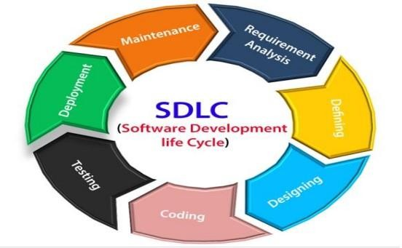

### Phases of SDLC

The SDLC typically consists of the following stages:

1. Planning and Requirement Analysis
2. Feasibility Study
3. System Design
4. Implementation (Coding)
5. Testing
6. Deployment
7. Maintenance

### Planning and Requirement Analysis

* + **Objective**: To gather requirements and understand the purpose of the software, the problems it needs to solve, and the needs of its users.

### Activities:

* + - Meeting with stakeholders, business analysts, and users to understand the requirements.
    - Identifying functional and non-functional requirements.
  + **Outcome**: Clear understanding of the project objectives, customer needs, and a roadmap for the development process.

### Feasibility Study

* + **Objective**: To determine whether the project is feasible to execute within the given constraints (time, budget, resources, technology).

### Activities:

* + - Analyzing the technical, operational, and financial feasibility of the project.
    - Identifying risks and potential roadblocks.
* **Outcome**: The team determines whether the project is viable and if it should proceed to the next stage.

### System Design

* + **Objective**: To create the architecture and design of the system based on the requirements gathered and the feasibility study.

### Activities:

* + - High-level design (HLD) and low-level design (LLD) creation.
    - Choosing the programming languages, tools, and platforms for development.
  + **Outcome**: A blueprint for the development process, outlining how the system will be structured and how components will interact.

### Implementation (Coding)

* + **Objective**: To translate the system design into actual code using the selected technologies and development tools.

### Activities:

* + - Writing the source code based on the design documents.
    - Integration of different modules or components.
  + **Outcome**: The working software code that implements the functionalities defined in the design phase.

### Testing

* + **Objective**: To ensure the software functions as expected, and meets the quality standards. The testing phase verifies the correctness, reliability, and security of the software.

### Activities:

* + - Identifying and fixing bugs or defects.
    - Ensuring the software meets performance, security, and usability requirements.
  + **Outcome**: A quality-assured software product ready for deployment. Any identified issues are resolved before moving to production.

### Deployment

* + **Objective**: To make the software available to end-users and stakeholders.

### Activities:

* + - Deploying the software to the production environment.
    - Configuring the system for real-world use.
  + **Outcome**: The software is now live and ready to be used by the end-users.

### Maintenance

* + **Objective**: To ensure that the software remains functional, up-to-date, and free from issues once it's deployed.

### Activities:

* + - Monitoring system performance and resolving any operational issues.
    - Handling user feedback and making necessary improvements.
  + **Outcome**: A continuously improving system that adapts to user needs, fixes bugs, and handles changing environments.

# ACTIVITY-03

## Overview of XP-XP practices

**Extreme Programming (XP)** is an agile software development methodology that emphasizes technical excellence, flexibility, and collaboration between developers and stakeholders. It was introduced by Kent Beck in the late 1990s, primarily for improving the quality of software and responsiveness to changing customer requirements.

XP is particularly well-suited for projects with rapidly changing or uncertain requirements. It focuses on improving the quality of software and enhancing the developer's ability to adapt to changing needs by promoting high levels of communication, continuous feedback, and frequent delivery of small software increments.

Here’s an overview of key **XP practices**:

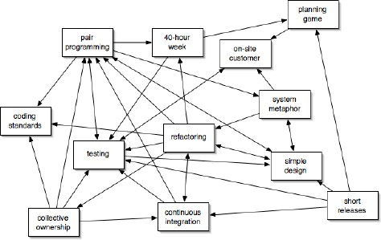

### Pair Programming

* + Two developers work together at one workstation: one writes code, while the other reviews it.
  + Reduces the likelihood of defects since two minds are constantly reviewing the work.

### Test-Driven Development (TDD)

* + Encourages writing clean, modular, and maintainable code.
  + Helps identify bugs and issues early in the development cycle.

### Continuous Integration (CI)

* + Frequently integrate code into a shared repository, followed by automated testing.
  + Detects integration issues early, making it easier to identify bugs and reducing the risk of code conflicts.

### Refactoring

* + Continuously improve the design of the existing code without changing its functionality.
  + Refactoring helps maintain code simplicity and flexibility, reducing technical debt and ensuring the system remains easy to maintain.

### Collective Code Ownership

* + Anyone on the team can modify any part of the code at any time.
  + This encourages team collaboration, eliminates bottlenecks, and prevents single points of failure in the codebase.

### Simple Design

* + Build the simplest possible solution that works and satisfies the requirements.
  + Keeps the codebase clean, easy to understand, and free from unnecessary complexity, allowing for easier changes and additions in the future.

### Sustainable Pace

* + Developers should work at a pace that they can sustain indefinitely, typically no more than 40 hours per week.
  + Prevents burnout, improves productivity over time, and fosters long-term team health.

### Customer Collaboration

* + Customers (or product owners) are closely involved throughout the development process, providing feedback on the product in regular iterations.
  + Ensures that the product always meets the user’s needs and expectations and allows for adjustments based on customer feedback.

### Coding Standards

* + Maintain consistent coding conventions and best practices to ensure readability and maintainability of the code.
  + This reduces errors, ensures that code can be easily understood by all team members, and facilitates smoother code reviews.

### On-Site Customer

* + A representative of the customer is always available to answer questions and provide feedback.
  + This ensures that the development team has immediate access to clarifications, helps with decision-making, and improves the likelihood that the product meets customer needs.

### Small Releases

* + Deliver working software in small, frequent releases (often every 1–2 weeks).
  + This allows for quick feedback, minimizes risk, and ensures that the project stays on track by validating assumptions early.

### Iterative Development

* + Work is done in short, iterative cycles that allow for frequent releases and feedback from stakeholders. Helps teams quickly adapt to changing requirements and reduces the cost of changes.

# ACTIVITY-04

## Categories of risk

Risks can be classified into several categories, depending on the context (e.g., business, project management, finance, etc.). Here are some common categories of risks:

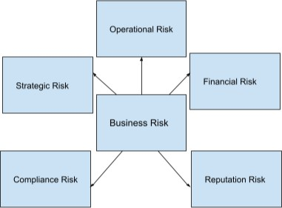

### Strategic Risks

* + **Description:** Risks that arise from the long-term strategy of an organization. They may involve changes in the competitive environment, market conditions, or shifts in consumer behavior.

### Examples:

* + - New competitors, market trends, regulatory changes.
    - Inability to adapt to industry trends.
    - Misalignment between the project and business strategy.

### Operational Risks

* + **Description:** Risks related to the internal processes, systems, and resources of an

organization. These risks can impact daily operations and affect efficiency and productivity.

### Examples:

* + - Equipment failure, supply chain disruptions, human error.
    - Delays in infrastructure setup or resource provisioning.
    - Team member turnover or skill gaps.

### Financial Risks

* + **Description:** Risks associated with financial transactions, capital structure, and the management of assets and liabilities.

### Examples:

* + - Currency exchange rate fluctuations, interest rate changes, credit risks, liquidity issues.
    - Cost overruns due to poor estimation or unexpected expenses.
    - Delays leading to financial penalties.

### Compliance/Legal Risks

* + **Description:** Risks arising from the failure to comply with laws, regulations, and industry standards. These risks can lead to legal penalties, fines, or damage to reputation.

### Examples:

* + - Non-compliance with labor laws, data protection regulations, tax obligations.
    - Contract disputes with vendors or clients.
    - Breach of intellectual property rights.

### Market Risks

* + **Description:** Risks related to changes in market conditions, including supply and demand fluctuations, market volatility, and price changes.

### Examples:

* + - Stock market crashes, commodity price fluctuations, market saturation.
    - Low demand for the product.
    - Changing customer requirements.

### Reputational Risks

* + **Description:** Risks that could damage an organization's reputation, trustworthiness, and public image.

### Examples:

* + - Negative press, social media backlash, product recalls.
    - If a company partners with an individual or another brand that later becomes involved in a scandal or controversy, it can reflect poorly on the company.
    - Collaborating with companies or individuals that are not aligned with the company’s values or reputation can lead to brand dilution and negative perceptions.

### Technological Risks

* + **Description:** Risks arising from technological changes or failures that can disrupt operations or lead to security breaches.

### Examples:

* + - Cybersecurity threats, software bugs, system failures, data breaches.
    - Integration challenges with other systems.
    - Inadequate testing leading to undetected defects.

### Project Risks

* + **Description:** Risks associated with specific projects, such as delays, scope creep, resource shortages, or failure to meet project objectives.

### Examples:

* + - Budget overruns, missed deadlines, scope changes, resource allocation issues.
    - Poor project planning or estimation.
    - Miscommunication among stakeholders.

# ACTIVITY-05

## Understanding the process of design thinking using an example

**a. Example of designing a new mobile app for meal planning**

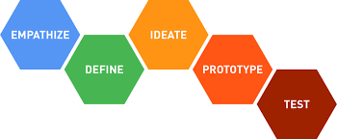

### Empathize (Understanding the User)

In this phase, the goal is to deeply understand the needs, challenges, and experiences of the users who will use the app. We want to observe and engage with potential users to gather insights into their pain points, desires, and goals related to meal planning.

### Activities:

* + **User Interviews**: Conduct interviews with people who struggle with meal planning, grocery shopping, or maintaining a healthy diet.
  + **Surveys**: Distribute surveys to get a wider perspective on users' needs, preferences, and existing behaviors when it comes to meal planning.
  + **Observations**: Observe users as they go through their meal planning process — either in their kitchens or when using existing meal planning tools or apps.

### Key Insights:

* + **Time Constraints**: Many users are busy professionals who want to save time in meal preparation.
  + **Dietary Needs**: Users want personalized meal plans based on specific dietary restrictions, such as keto, vegetarian, or gluten-free.
  + **Ingredient Management**: Users find it challenging to keep track of ingredients already available in their pantry and avoid food waste.

### Define (Problem Definition)

Based on the insights from the Empathize phase, we define the core problem that the meal planning app needs to solve. This is typically done by creating a Point of View (POV) and a Problem Statement.

### Point of View (POV):

* + Busy professionals and families need a tool that can simplify meal planning, help them create healthy meals within their dietary preferences, and reduce food waste by managing ingredients efficiently.

### Problem Statement:

* + “Users need an easy-to-use meal planning app that helps them plan meals based on their dietary needs, automatically generates shopping lists, and tracks ingredients in their pantry to minimize food waste and save time.”

### Ideate (Generating Ideas)

In the Ideate stage, we brainstorm possible solutions to address the problem. The goal is to come up with as many ideas as possible, without judging them at first, and then evaluate which ideas are most viable.

### Brainstorming Sessions:

* + **User-Centered Features**: Consider features that address user pain points:
    - **Personalized Meal Plans**: Users can input their dietary preferences (e.g., vegan, low-carb) and get recipe suggestions that fit their needs.
    - **Automatic Shopping Lists**: Based on the meal plan, the app generates shopping lists with all necessary ingredients, including quantities.
    - **Meal Prep Suggestions**: Provide suggestions for batch cooking or meal prep, with clear instructions for storing or reheating meals throughout the week.
    - **Pantry Inventory**: The app can track pantry inventory, so users can see what ingredients they already have, avoiding unnecessary purchases.

### Prototype (Building the Solution)

In this phase, we take the most promising ideas from the Ideate stage and start turning them into tangible, low-fidelity prototypes. Prototypes don’t need to be perfect; they’re meant to be quick, experimental models that help visualize and test the app’s functionality and design.

### Prototypes:

1. **Wireframes**
   * Home Screen: Simple interface showing quick access to meal plans, shopping lists, and recipes.
   * Meal Planner Screen: Users can select meals for the week via a drag-and-drop calendar interface.
   * Recipe Detail Screen: Each recipe displays ingredients, instructions, and nutritional information.
   * Shopping List: Automatically generated list based on selected meals, with a feature to check off ingredients already in the pantry.
2. **Clickable Mockups**: Create clickable prototypes using tools like Figma or InVision. This allows users to interact with the app and provides feedback on user flows and design elements.

### Basic Functionalities:

* + Meal planner with drag-and-drop functionality.
  + Basic shopping list generation based on selected recipes.

### Test (Refining the Solution)

In the Test stage, we gather feedback from real users by testing the prototype in realistic scenarios.

This is an iterative process, where we test the solution, analyze user responses, and refine the prototype accordingly.

### Testing Activities:

* + **Usability Testing**: Observe users as they interact with the app. Are they able to easily plan meals? Do they find the shopping list useful? Is it easy to add or remove ingredients from the pantry inventory?
  + **A/B Testing**: Test different versions of features or UI elements (e.g., different designs for the shopping list or meal planner) to determine which version works best for the users.

# ACTIVITY-06

## Requirement types

In software development, requirements refer to the specifications or conditions that a system, product, or project must fulfill. Requirements can be broadly categorized into different types, depending on their nature and purpose. Here are the main requirement types:

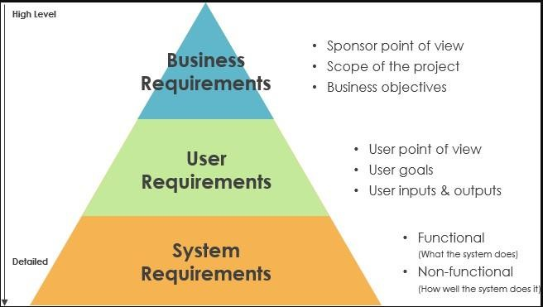

### Functional Requirements

* + These describe what the system must do.
  + They define the core functionality and features of the system.
  + **Example:** "The system shall allow users to register with a username and password."

### Non-Functional Requirements

* + These describe the quality attributes, system performance, or constraints.
  + Non-functional requirements typically specify how well the system should perform a task.
  + **Example:** "The system shall support 1,000 concurrent users" or "The system should respond within 2 seconds."

### Business Requirements

* + These are high-level requirements that focus on the goals and objectives from a business perspective.
  + They define the overarching goals of the project or system from the stakeholder's or organization’s point of view.
  + **Example:** "The system should help reduce operational costs by 15%."

### User Requirements

* + These focus on the needs and expectations of the users.
  + They describe what the users need or expect from the system to fulfill their tasks.
  + **Example:** "The system shall provide a user-friendly interface for managing inventory."

### System Requirements

* + These describe the technical aspects, components, and behavior of the system.
  + System requirements can be divided into hardware and software requirements.
  + **Example:** "The system shall run on Windows 10 and require at least 4 GB of RAM."

### Interface Requirements

* + These describe how the system will interact with other systems, hardware, or software.
  + They outline the necessary protocols, APIs, or data formats for system integration.
  + **Example:** "The system shall integrate with the existing payroll system via a RESTful API."

### Regulatory and Compliance Requirements

* + These are requirements driven by laws, regulations, or standards that the system must comply with.
  + **Example:** "The system must comply with the GDPR (General Data Protection Regulation)."

### Performance Requirements

* + These focus on how well the system must perform under certain conditions (e.g., speed, availability, capacity).
  + **Example:** "The system should handle up to 10,000 transactions per minute."

### Security Requirements

* + These describe the security features, measures, and controls that need to be in place to protect the system and its data.
  + **Example:** "The system shall encrypt sensitive data using AES-256."

### Usability Requirements

* + These focus on the ease of use, accessibility, and user experience of the system.
  + **Example:** "The system should provide tooltips for all form fields."

### Operational Requirements

* + These describe the conditions under which the system will operate, including maintenance and support considerations.
  + **Example:** "The system must be operational 24/7 with a maximum downtime of 2 hours per year."

### Safety Requirements

* + These describe the measures to be taken to ensure the system operates safely, especially in critical environments (e.g., medical or automotive systems).
  + **Example:** "The system shall shut down automatically if a safety threshold is exceeded."

### Quality Requirements

* + These include expectations around the reliability, maintainability, and overall quality of the system.
  + **Example: "**The system should have an uptime of 99.9%."

# ACTIVITY-07

## Components of story point estimation

Story point estimation is a technique used in Agile methodologies, particularly Scrum, to estimate the effort required to complete a user story or task. It focuses on relative effort rather than absolute time, considering various factors like complexity, size, and uncertainty. Here are the key components of story point estimation:

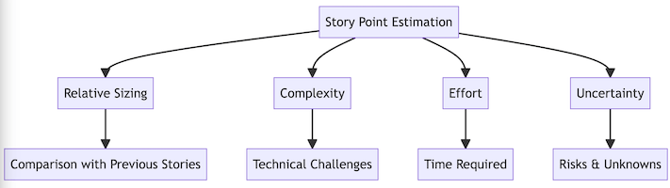

### Complexity

* + **Definition**: The inherent difficulty of implementing a user story or task. A complex task might involve complex algorithms, integrations with external systems, or understanding difficult business logic.

### Factors to Consider:

* + - Amount of research required.
    - Level of technical complexity or novelty.
    - Dependencies on other tasks or teams.

### Effort

* + **Definition**: The amount of work (or the number of tasks) that needs to be done to complete the story. A task that requires more coding, design, or testing might be considered to have higher effort.

### Factors to Consider:

* + - Number of components involved (e.g., UI, database, backend logic).
    - Extent of coding or design needed.
    - Time-consuming tasks like testing and documentation.

### Uncertainty or Risk

* + **Definition**: The amount of unknowns or uncertainty involved in the task. If a task is poorly understood or there are risks that could affect the scope or effort required, it will have higher uncertainty.

### Factors to Consider:

* + - Lack of clarity in requirements or user stories.
    - Need for exploration or prototyping.
    - Dependencies on external systems, technologies, or teams that might not be fully known or controlled.

### Size

* + **Definition**: The overall size or magnitude of the user story. Larger stories (epics) require more work and are broken down into smaller tasks (user stories). A larger story will have more complexity and effort.

### Factors to Consider:

* + - The number of features involved in the story.
    - The number of interactions with other systems or components.
    - The scale at which the solution needs to work (e.g., global versus local functionality).

### Team Experience

* + **Definition**: The familiarity and experience of the team with the technology or domain related to the user story. If the team has a lot of experience with the task, the story will generally have fewer points, as they can complete it more efficiently.

### Factors to Consider:

* + - Familiarity with the technology stack or frameworks.
    - Past experience with similar user stories or tasks.
    - Team knowledge about business logic or customer requirements.

### Time Sensitivity

* + **Definition**: The urgency or critical nature of the task. While story points don’t directly represent time, time sensitivity may influence how quickly or urgently the task is prioritized. This is typically considered during sprint planning but not directly factored into the story points.

### Factors to Consider:

* + - Deadlines or customer commitments.
    - Regulatory or compliance requirements that must be met.
    - Impact of the feature on the product's success.

### Dependencies

* + **Definition**: The dependencies that exist with other stories, teams, or systems. A story that relies on other tasks or external teams will be harder to estimate, as it involves additional

coordination and waiting time.

### Factors to Consider:

* + - Dependencies on other user stories.
    - External APIs or third-party integrations.
    - Coordination with different teams (e.g., design, QA, or operations).

### Why Use Story Points?

* **Focus on Relative Effort**: Story points allow teams to focus on how difficult or complex a story is relative to other stories, instead of getting caught up in exact time estimates.
* **Encourages Collaboration**: Estimating as a team encourages discussion, knowledge sharing, and a clearer understanding of what’s involved in a task.
* **Improves Forecasting**: Over time, as teams track their velocity (the number of story points completed in each sprint), they can better predict how much work they can complete in future sprints.

# ACTIVITY-08

## Software Design Concepts

Software design concepts refer to the principles, patterns, and practices used to structure and organize software systems. These concepts help ensure that the system is modular, maintainable, scalable, and flexible. Here are some of the key software design concepts:

### Modularity

* + **Definition**: Modularity refers to breaking down a software system into smaller, self-contained modules that each handle a specific part of the functionality.

### Benefits:

* + - Easier to manage and maintain.
    - Each module can be developed, tested, and debugged independently.
    - Promotes reusability — modules can be reused in other systems or components.
  + **Example**: A content management system (CMS) might be broken into modules like user authentication, content creation, and media management.

### Abstraction

* + **Definition**: Abstraction hides the complexity of a system by providing a simple interface, focusing only on essential details and ignoring the irrelevant ones.

### Benefits:

* + - Simplifies interaction with complex systems.
    - Makes the system easier to understand and use.
    - Allows for focusing on high-level functionality while hiding low-level implementation details.
  + **Example**: A file system allows you to interact with files without needing to understand how the data is physically stored on the disk.

### Encapsulation

* + **Definition**: Encapsulation is the concept of bundling data (attributes) and methods (functions) that operate on the data into a single unit, typically a class, and restricting access to some of the object's components.

### Benefits:

* + - Protects the internal state of the object and prevents unintended interference.
    - Provides controlled access to the object's attributes through methods (getters and setters).
    - Enhances modularity and security.
  + **Example**: A BankAccount class encapsulates the balance attribute and provides methods like deposit() and withdraw() to interact with it.

### Reusability

* + **Definition**: Reusability is the design principle of creating software components that can be used across different applications or systems.

### Benefits:

* + - Reduces redundancy and time spent writing code.
    - Promotes consistency across systems.
    - Lowers the cost of future development.
* **Example**: A payment processing module can be reused across multiple applications that require similar functionality.

### Scalability

* + **Definition**: Scalability refers to the system's ability to handle increasing workloads or the potential to grow and accommodate more data, users, or transactions.

### Benefits:

* + - Ensures the system can grow as user needs increase.
    - Minimizes the need for major changes as the system expands.
  + **Example**: A web application designed to scale horizontally by adding more servers to handle increased traffic is considered scalable.

### Loose Coupling and High Cohesion

* + **Loose Coupling**: Loose coupling refers to minimizing the dependencies between different modules or components in the system. When components are loosely coupled, changes to one module have minimal impact on others.
    - **Benefits**: Improves system flexibility and maintainability, as components can evolve independently.
    - **Example**: Microservices architecture is a good example where each service is independently deployable and interacts with others via well-defined APIs.
  + **High Cohesion**: High cohesion refers to designing components or modules that focus on a single, well-defined task, making them highly focused and logically connected.
    - **Benefits**: Easier to maintain and test as each module has a specific, narrow responsibility.
    - **Example**: A logging module that only handles logging functions, not involving any other unrelated functionalities.

### Maintainability

* + **Definition**: Maintainability is the ease with which software can be updated, modified, or debugged over time. It is a key factor in long-term software success.

### Benefits:

* + - Easier to fix bugs and apply updates or improvements.
    - Reduces technical debt and avoids large rewrites of code.
  + **Example**: Writing clean, modular code with thorough documentation makes future maintenance easier.

### Security

* + **Definition**: Security involves designing software in a way that protects it from threats and unauthorized access, ensuring data privacy and integrity.

### Benefits:

* + - Safeguards sensitive data from being exposed or manipulated.
    - Builds user trust and ensures compliance with legal and regulatory standards.
  + **Example**: Implementing encryption for sensitive data, using secure authentication (like multi- factor authentication), and performing regular security audits.

# ACTIVITY-09

## DevOps practices

DevOps practices are the set of methodologies and techniques used to integrate software

development (Dev) and IT operations (Ops) with the aim of delivering applications and services faster, more efficiently, and with better quality. These practices help teams automate, monitor, and improve the entire software delivery lifecycle. Here are the key DevOps practices:

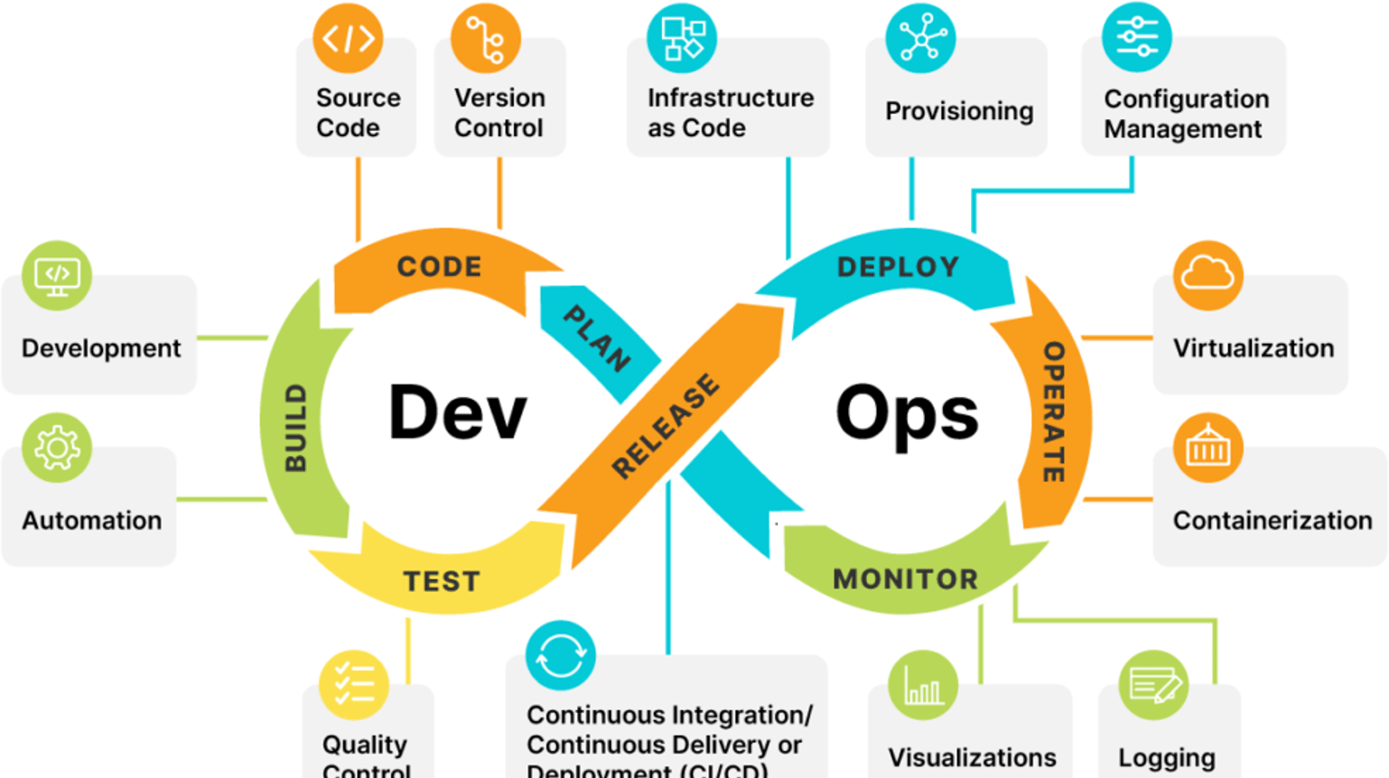

### Continuous Integration (CI)

* + **Definition**: CI is the practice of automatically integrating code changes into a shared repository multiple times a day. Every time a developer commits code, it’s automatically tested and integrated.
  + **Benefit**: This helps detect bugs early, streamline the development process, and avoid integration issues.
  + **How**: Developers push their code to a shared version control system like Git, where an automated build and test process is triggered to validate the code.
  + **Tools**: Jenkins, Travis CI, GitLab CI, CircleCI.

### Continuous Delivery (CD)

* + **Definition**: Continuous Delivery extends CI by automatically deploying code to staging or production environments after passing integration tests, ensuring that the code is always ready for production.
  + **Benefit**: It reduces the manual effort of deploying applications, accelerates time to market, and minimizes the risk of errors during deployment.
  + **How**: Once code passes tests in the CI pipeline, it is automatically deployed to a staging

environment. After further validation, it can be deployed to production with minimal manual intervention.

* + **Tools**: Jenkins, Spinnaker, Bamboo, GitLab CI.

### Continuous Testing

* + **Definition**: Continuous testing involves automating the testing process to run tests continuously throughout the development lifecycle, ensuring high-quality code.
  + **Benefit**: Ensures defects are caught early, reducing the likelihood of bugs reaching production. It also provides rapid feedback to developers.
  + **How**: Tests are executed automatically every time new code is integrated or deployed. This includes unit tests, integration tests, system tests, and performance tests.
  + **Tools**: Selenium, JUnit, TestNG, Postman.

### Infrastructure as Code (IaC)

* + **Definition**: IaC is the practice of managing and provisioning infrastructure through code and automation rather than manual processes.
  + **Benefit**: It improves consistency, reduces configuration drift, and makes infrastructure scalable and replicable across environments.
  + **How**: Infrastructure configurations are written in code (using scripts or configuration files) and stored in version control. This allows infrastructure to be versioned, reviewed, and tested just

like application code.

* + **Tools**: Terraform, Ansible, Puppet, Chef, CloudFormation.

### Configuration Management

* + **Definition**: Configuration management ensures that all systems in the environment are set up and maintained in a consistent manner.
  + **Benefit**: It reduces errors and improves system reliability by automating the setup, configuration, and maintenance of systems.
  + **How**: Configuration management tools automate system configurations, updates, and management of servers, ensuring consistency across environments.
  + **Tools**: Ansible, Chef, Puppet, SaltStack.

### Monitoring and Logging

* + **Definition**: Monitoring involves continuously tracking the system’s performance, availability, and overall health. Logging involves collecting and analyzing log data to identify issues.
  + **Benefit**: It helps teams identify and respond to issues quickly, improving system reliability and user experience.
  + **How**: Real-time monitoring of servers, applications, and services is done, and logs are collected to troubleshoot errors and gain insights into system behavior.
  + **Tools**: Prometheus, Grafana, ELK stack (Elasticsearch, Logstash, Kibana), Splunk, Datadog.

### Collaboration and Communication

* + **Definition**: DevOps emphasizes communication and collaboration between development and operations teams throughout the software lifecycle.
  + **Benefit**: Fosters a culture of shared responsibility, which leads to faster feedback, quicker resolutions, and more cohesive teams.
  + **How**: Teams use collaborative tools and adopt practices such as joint planning, regular feedback loops, and cross-functional collaboration.
  + **Tools**: Slack, Microsoft Teams, Jira, Confluence, Trello.

# ACTIVITY-10

## Benefits of containerization

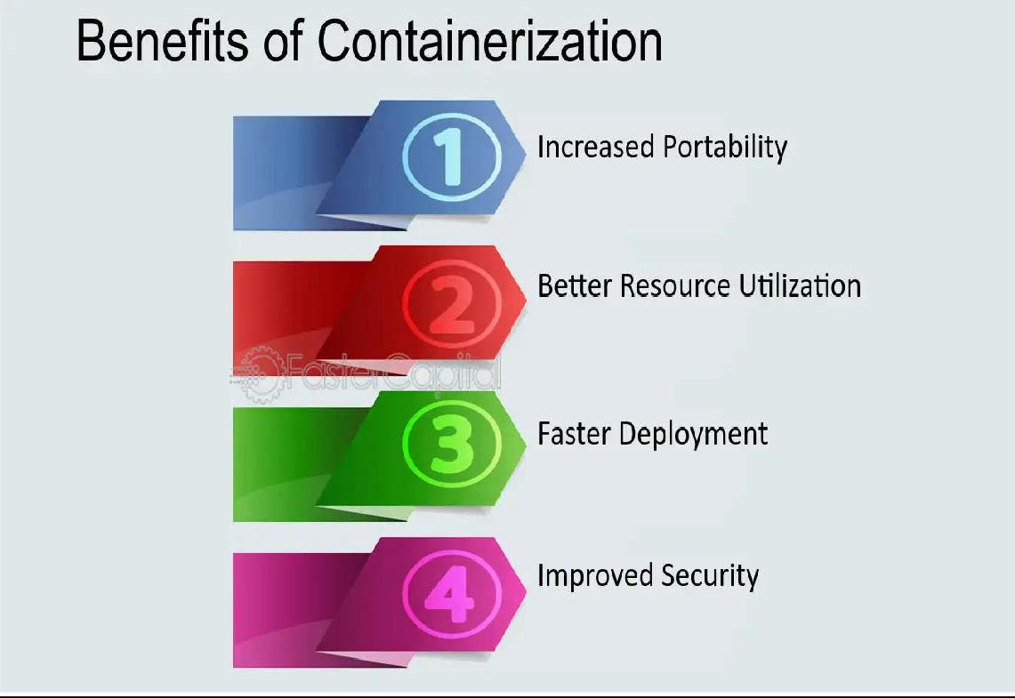Containerization is a powerful technology that encapsulates an application and its dependencies into a container. It has gained significant popularity due to its numerous benefits, especially in the context of modern software development, deployment, and operations. Here are the key benefits of containerization:

### Portability

* + **Consistency Across Environments**: Containers package an application with all its dependencies, including libraries, configurations, and binaries.
  + **Cross-Platform Support**: Containers are platform-independent and can be run on various operating systems like Linux, Windows, and macOS, as long as the host supports containerization.
  + **Benefit**: Containers are platform-independent and can run consistently across different environments.

### Lightweight and Fast

* + **Efficient Resource Utilization**: Containers are much more lightweight than virtual machines because they don't require a full operating system. Containers share the host's OS kernel, allowing for multiple containers to run on the same host without significant overhead.
  + **Faster Startup Time**: Since containers do not need to boot up an entire operating system, they can start in a fraction of the time it takes for a virtual machine to boot, leading to quicker

deployments and improved application scaling.

* + **Benefit:** Containers share the host OS kernel, reducing overhead and improving efficiency.

### Isolation

* + **Process Isolation**: Each container runs in its own isolated environment, meaning that applications in different containers do not interfere with each other. This isolation improves security and ensures that the failure of one container does not affect the others.
  + **Dependency Isolation**: Containers also isolate application dependencies. This allows for different applications to run on the same host system without worrying about dependency conflicts (e.g., different versions of a library or framework).
  + **Benefit**: Containers isolate applications and their dependencies, improving security and reducing conflicts.

### Scalability and Flexibility

* + **Easy Scaling**: Containers can be quickly replicated and distributed to scale applications horizontally. This is particularly beneficial in microservices architectures where different components of an application are containerized and can be independently scaled.
    - **Elasticity**: Containers, when orchestrated with tools like Kubernetes, can be automatically scaled up or down based on demand. This elasticity improves resource usage and reduces costs.
    - **Benefit**: Containers can be quickly deployed, stopped, and scaled to meet demand. Supports microservices architecture, enabling modular development and independent scaling.

### Cost Efficiency

* + **Optimized Resource Usage**: Since containers are lightweight and share the same kernel, they require fewer system resources compared to virtual machines. This leads to more efficient

resource utilization and allows more applications to run on the same infrastructure, which can reduce costs.

* + **Cloud-Native Benefits**: Containers are designed for cloud environments, making them well- suited for cloud-native applications. This can take advantage of cloud features like elastic scaling, pay-as-you-go pricing, and resource optimization.
  + **Benefit**: By running containers on a shared OS kernel, they consume fewer system resources compared to virtual machines. This reduces the need for expensive hardware and optimizes resource usage in cloud environments.

### Faster Development& Deployment

* + Quick deployment is crucial for Continuous Integration/Continuous Deployment (CI/CD) pipelines, enabling faster release cycles and quicker scaling of services.
  + During periods of high demand, you can quickly spin up additional containers to handle the increased load and spin them down when traffic decreases.
  + Developers can build, test, and deploy application faster.
  + Continuous Integration/Continuous Deployment (CI/CD) becomes seamless.
  + **Benefit**: Containers are fast to deploy because they don't need to boot up an entire operating system. Containers can start in a matter of seconds, whereas virtual machines can take several minutes to boot.

# ACTIVITY-11

## Stages of Testing

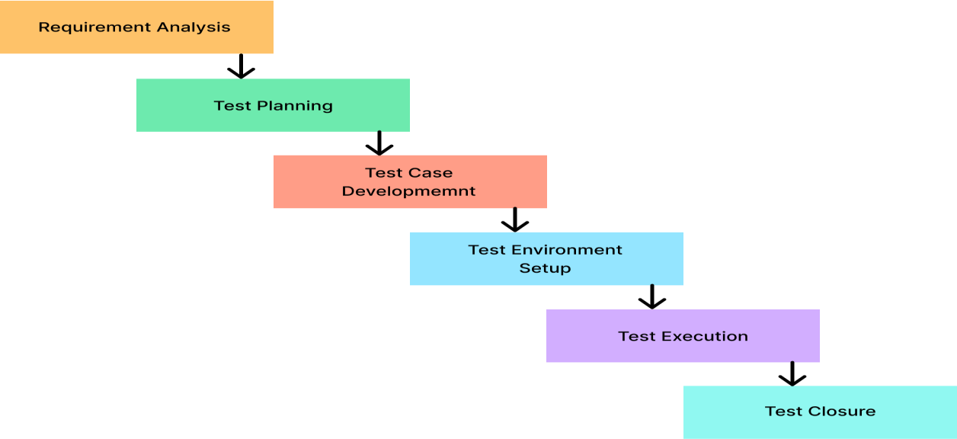

### Requirement Analysis

* + **Objective**: Understanding and analyzing the requirements of the software to identify testable requirements and to design a testing strategy.

### Activities:

* + - Review software requirements, including business, functional, and non-functional specifications.
    - Identify the type of testing required (e.g., functional, performance, security).
    - Involve both developers and business analysts to clarify ambiguities.

### Deliverables:

* + - Testable requirement document
    - Test plan and strategy outline

### Test Planning

* + **Objective**: Defining the scope, approach, resources, and schedule for testing. This stage involves creating a test plan.

### Activities:

* + - Define the test objectives (what is to be tested).
    - Create a Test Plan that outlines testing objectives, testing scope, methodology, resource requirements, schedule, and entry/exit criteria.
    - Assign roles and responsibilities to the testing team.

### Deliverables:

* + - Test plan document
    - Test environment setup plan

### Test Design

* + **Objective**: Designing the actual test cases and preparing the test data.

### Activities:

* + - Create detailed test cases based on the requirements and use cases.
    - Define test data required for executing the test cases.
    - Review and validate the test cases to ensure they are clear, comprehensive, and traceable to requirements.

### Deliverables:

* + - Test case documents
    - Test scripts (for automation)

### Test Environment Setup

* + **Objective**: Preparing the environment where testing will occur.

### Activities:

* + - Set up the test environment (hardware, software, network, databases, etc.).
    - Ensure the test environment mirrors the production environment as closely as possible.
    - Ensure that the environment supports the type of testing being done (e.g., performance, integration).

### Deliverables:

* + - Test environment setup
    - Required test data configured

### Test Execution

* + **Objective**: Executing the test cases and logging the results.

### Activities:

* + - Log defects and issues found during testing, detailing the severity and priority.
    - Perform regression testing when required after defect fixes.
    - Track the progress of test execution and update the status of each test case (Pass/Fail).

### Deliverables:

* + - Test case execution logs
    - Defect logs

### Test Closure

* + **Objective**: Finalizing the testing phase and closing the testing activities.

### Activities:

* + - Verify that all test cases have been executed and that all defects have been resolved or documented.
    - Perform final regression testing to ensure no new issues have been introduced.
    - Handover the testing deliverables (test cases, defect logs, reports) to the appropriate stakeholders.

### Deliverables:

* + - Test closure report
    - Lessons learned

# ACTIVITY-12

## Application Monitoring

Application Monitoring refers to the continuous process of observing and tracking the

performance, health, and availability of software applications to ensure they are functioning optimally. This is done using a variety of tools and techniques to monitor different aspects such as response time, server resource usage, uptime, and user experience. The goal is to proactively identify and resolve issues before they impact the user experience or application availability.

### Key Aspects of Application Monitoring:

1. **Performance Monitoring**:
   * **Description**: This involves measuring how well an application performs in real-time. It includes response times, throughput, and resource usage (e.g., CPU, memory, disk usage).
   * **Why it matters**: Poor performance leads to slow applications, which can frustrate users and hurt retention. Monitoring performance ensures smooth operation and optimal user

experience.

### Examples:

* + - Latency in API calls.
    - Page load times.
    - Response times for various transactions.

### Availability Monitoring:

* + **Description**: Availability monitoring checks if an application, service, or server is available and operating as expected. This is usually done by pinging the application periodically.
  + **Why it matters**: Downtime or interruptions can lead to loss of business, decreased user satisfaction, and poor service reputation. Continuous monitoring ensures that the system is always available for users.

### Examples:

* + - Server uptime tracking.
    - Service availability checks (e.g., database or web server).

### Error Monitoring:

* + **Description**: Error monitoring tracks any failures or issues that arise during the application's execution, such as bugs, crashes, or unhandled exceptions.
  + **Why it matters**: Unresolved errors can lead to broken functionality and a poor user experience. By monitoring errors, teams can quickly identify and fix issues, improving stability and reliability.

### Examples:

* + - Uncaught exceptions or runtime errors.
    - Database connection failures.

### Log Monitoring:

* + **Description**: This involves collecting and analyzing logs generated by the application and its components, such as web servers, databases, and backend services.
  + **Why it matters**: Logs provide detailed insights into the behavior of an application, allowing teams to troubleshoot and identify issues effectively.

### Examples:

* + - Error logs.
    - System performance logs.
    - Event logs from various components.

### User Experience Monitoring (RUM):

* + **Description**: Real User Monitoring (RUM) tracks user interactions with the application in real-time. It focuses on how the end-users experience the application, providing data on

page load times, interaction delays, and user actions.

* + **Why it matters**: Ensuring a smooth and responsive user experience is critical to user satisfaction and retention. Monitoring real user experiences helps identify areas for

improvement in the user interface or application performance.

### Examples:

* + - Monitoring how long it takes for a user to load a page.
    - Tracking how users navigate through the app.

### Infrastructure Monitoring:

* **Description**: Monitoring the underlying infrastructure (e.g., servers, databases, networks) that supports the application is critical for understanding how resources are being used and whether there are any potential issues affecting the application’s performance.
* **Why it matters**: Bottlenecks in the infrastructure (e.g., high CPU usage, low memory availability) can directly impact application performance. Monitoring infrastructure allows teams to detect and resolve problems early.

### Examples:

* + Server CPU usage.
  + Database response times.
  + Network latency or congestion.

**ACTIVITY-13**

**Quality Assurance**

**What is Quality Assurance (QA)?**

At its core, Quality Assurance (QA) is about building quality into every step of a process. It is a proactive approach that focuses on designing systems, processes, and standards that prevent defects from arising, rather than fixing them after they occur. QA encompasses a set of activities, tools, and techniques that help organizations ensure the effectiveness and efficiency of their processes. The goal of QA is to consistently meet or exceed customer expectations by delivering high-quality products and services.

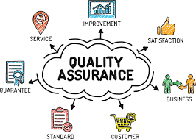

**Key Principles of Quality Assurance**

1. **Prevention Over Detection**  
   QA emphasizes preventing defects during production rather than detecting them after the fact. The idea is that identifying and correcting problems early saves time, money, and resources in the long run.
2. **Process-Oriented**  
   The focus of QA is on optimizing the processes used in the creation or delivery of a product or service. Well-defined, repeatable processes ensure consistency and quality across all outputs.
3. **Customer Satisfaction**  
   QA always keeps the customer in mind. It aims to ensure that products and services meet or exceed customer expectations, both in terms of functionality and overall quality.
4. **Continuous Improvement**  
   QA encourages ongoing improvement through feedback loops, audits, and monitoring of performance. Methods like **Plan-Do-Check-Act (PDCA)** and **Total Quality Management (TQM)** help organizations refine processes over time.
5. **Standardization and Consistency**  
   By establishing clear standards and guidelines for production or service delivery, QA helps organizations ensure that all products and services are consistent and reliable.

**The Role of Quality Assurance in Various Industries**

1. **Manufacturing Industry**  
   In manufacturing, QA involves setting up processes to ensure that every product is produced to the highest standards. This might include designing efficient workflows, ensuring proper training for workers, maintaining equipment, and conducting regular process audits. QA teams focus on process control and monitor critical parameters to minimize defects.
2. **Software Development**  
   In software development, QA ensures that software is functional, secure, and user-friendly. QA engineers work to define clear requirements and testing criteria before the coding begins. They conduct various forms of testing (e.g., unit testing, integration testing, acceptance testing) and focus on preventing bugs and performance issues before the software is released to users.
3. **Healthcare**  
   In healthcare, QA is used to ensure that care standards are followed, reducing medical errors and improving patient safety. Healthcare organizations use QA processes to review clinical practices, verify equipment and medication accuracy, and ensure compliance with regulatory standards.
4. **Service Industries**  
   For service industries such as hospitality, QA ensures that services meet customer expectations consistently. Whether it’s a hotel, restaurant, or financial service, QA processes involve monitoring employee performance, customer feedback, and ensuring adherence to service standards.

**Key Tools and Methodologies in QA**

1. **ISO 9001**  
   ISO 9001 is an internationally recognized standard for Quality Management Systems (QMS). It provides a framework for establishing a quality management system, ensuring consistent product quality and continuous improvement in processes.
2. **Six Sigma**  
   Six Sigma is a methodology aimed at improving quality by identifying and eliminating causes of defects and variation. It uses statistical methods to ensure processes are efficient and within defined tolerances, achieving no more than 3.4 defects per million opportunities.
3. **Plan-Do-Check-Act (PDCA)**  
   The PDCA cycle is a continuous improvement model used in QA to ensure that processes are consistently evaluated and improved. It involves four steps:
   * **Plan**: Define objectives and processes to achieve them.
   * **Do**: Implement the plan and collect data.
   * **Check**: Review the data and compare performance to expectations.
   * **Act**: Take corrective actions based on the results.
4. **Failure Mode and Effects Analysis (FMEA)**  
   FMEA is a proactive tool used to identify potential failures in a process or product before they occur. It helps prioritize risks based on their severity, likelihood, and impact, allowing teams to take corrective actions before defects happen.
5. **Root Cause Analysis (RCA)**  
   RCA is used when problems arise to identify the underlying causes rather than just treating symptoms. This helps organizations fix the problem at its source and prevent recurrence.
6. **Benchmarking**  
   Benchmarking involves comparing an organization's processes, performance, and practices against industry best standards or competitors. It helps identify areas for improvement and implement best practices.

**Benefits of Quality Assurance**

1. **Enhanced Customer Satisfaction**  
   QA ensures that products or services meet customer expectations consistently, leading to higher satisfaction and loyalty.
2. **Reduced Costs and Waste**  
   By preventing defects and inefficiencies early in the process, QA helps organizations save costs related to rework, returns, or recalls.
3. **Compliance with Standards and Regulations**  
   QA helps organizations adhere to industry standards and regulations, ensuring compliance with legal requirements and reducing the risk of penalties or reputational damage.
4. **Improved Process Efficiency**  
   By optimizing processes and eliminating unnecessary steps, QA leads to more efficient operations, reducing time and resource waste.
5. **Continuous Improvement**  
   QA fosters a culture of continuous improvement, helping organizations adapt to changes and refine their processes over time.